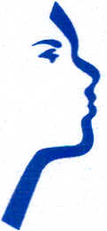
Jeffrey R. LeSueur, M.D., P.C.
5448 S. White Mountain Rd., Suite 140
Lakeside, AZ 85929
928-532-0072
Fax: 928-532-0078

Eustachian Tube Clearing Instructions

If you are having problems clearing your ears and will be changing altitude (i.e.: flying in a plane or driving from the mountains to the valley), please follow these instructions:

½ hour prior to altitude change, spray Oxymetazoline (Afrin, Equate, 4-way) copiously into each nostril.

After 10 minutes, as much as possible, lay on your back with your nose up and head way back, spray copiously again to get the Afrin into the Eustachian tube.

This will taste terrible and may give a burning sensation in you throat – this is normal. It usually takes approximately 15 minutes to clear the ear/open the Eustachian tube.

**Do not use Oxymetazoline daily/frequently – it will raise your blood pressure if overused**

